BUNNELL BONNELL BUNNELL BONNELL BUNNELL BONNELL BUNNELL BONNELL BUNNELL B
UNNELL | THE BUNNELL/BONNELL NEWSLETTER |  |  |  | ONNE  L  L
B |  |  |  |  | B
O | Volume VII, No. 2. |  |  | 1 April 1993 | U
N  N  E  L  L |  | Published by  William R. Austin  P. O. Box 62  Laceyville, PA 18623  (717) 869-2325 |  |  | N  NE  L  L
BUNNELL BONNELL BUNNELL BONNELL BUNNELL BONNELL BUNNELL BONNELL BUNNELL B

COMMENT

Since the last Newsletter was prepared, I discovered PRODIGY. This is a service available on the computer which provides, among other things, a Genealogy Bulletin Board. Any subscriber can place queries on the Bulletin Board for whatever family is of interest. Other subscribers who may be researching the same family can then respond on the computer screen.

James Bonnell, Merced, CA, first brought prodigy to my attention. I subscribed, and was delighted to meet on the Bulletin Board a number of new Bunnell and Bonnell correspondents, several of whom have subscribed to the Newsletter. My ID number is HNWB08A.

My only concern with PRODIGY is the cost. The monthly subscription charge is reasonable, but since I do not live within the calling area in one of the many cities where prodigy is located, each time I sign on I have to pay long-distance telephone charges to Wilkes-Barre. After the first couple of horrendous telephone bills, I have learned to temper my use of the service.

* * * * * *

I received a telephone call from Col. Quentin Keith, Red Bank, NJ. He is a retired English professor with a fine taste in books. At an auction he bought the diary or journal of Samuel Bonnell, Jr., kept from 1848 to 1855. Samuel CB002195, son of Samuel and Cornelia Clarkson (Bringhurst) Bonnell, was born 29 February 1824 in Philadelphia, Pa. Fascinated by the insights the diary provides to this period in our history. Col. Keith is pursuing research to learn more about the family and its relationships in Philadelphia and Wilkes-Barre, PA, Brooklyn, NY, Charleston, SC, and New Orleans, LA. He may want to publish the diary in the future. Claude Bunnell and I have given him what information we have about the family and will help in any way we can to further his project.

* * * * * *

LAFAYETTE HOUGHTON BUNNELL

Several correspondents have asked me about Lafayette Houghton Bunnell CB320352, one of the discoverers of the Yosemite Valley. He was descended from William Bunnell, the immigrant, through Benjamin, Benjamin, Gershom, and Job to his father Dr. Bradley Bunnell, who married Charlotte Houghton. Although Lafayette has no direct descendants, since he never had any children of his own, his career was so interesting as to warrant including an account of it in the Newsletter.

His father was a physician, a native of Fairfield co, CT; his mother was born in Vermont. They married in Vermont and began to raise a family there. They are said to have had twelve children, six of whom grew to adulthood. By 1814 they had moved to Homer, Cortland co, NY, where Lafayette's older brother Willard Bradley was born. The 1820 census found them in Barre, Genesee (now Orleans) co, NY. Their next move took them to Rochester, Monroe co, MY. Lafayette Houghton Bunnell was born there 13 March 1824.

They were still living in Rochester when the 1830 census was taken, but two or three years later Dr. Bunnell removed his family to Detroit, MI. Here, on the edge of the frontier, Lafayette grew up, acquiring, along with an education in the classics, a useful knowledge of the customs and language of the Chippewa Indians.

Bradley Bunnell wanted Lafayette to follow in his own footsteps and become a doctor. When he was 16 years old, after a short experience working as a salesman and collector for a pharmaceutical company, Lafayette reluctantly began to study medicine in his father's office. He endured this for a couple of years, then followed his trader brother Willard to Wisconsin, and took up 160 acres at LaCrosse.

He came back to Detroit in 1844 and entered the office of a Dr. Scoville, to continue the study of medicine. His studies were interrupted by the Mexican War. On 2 November 1847 he enlisted in Company B, First Regiment, Michigan Volunteer Infantry, and was mustered in as a Hospital Steward. The DETROIT SOCIETY OF GENEALOGICAL RESEARCH MAGAZINE, Vol. 41, #1, Fall 1977, has the following:
"Descriptive Roll of the First Regiment of Michigan Volunteers 1847-1848: Lafayette H. age 25 years. Height 5'10". Light complexion, dark eyes and hair. Born in Rochester, N. Y. Druggest. Appointed Hospital Steward 12 Nov. 1847."

Lafayette did not participate in any of the engagements of the war, since he did not enlist until after the termination of hostilities. The American forces were in complete control of all Mexican strong points by the end of October 1847. The War Department records show that Lafayette Bunnell was a hospital steward at Cordova. One account states, "During the illness of the doctors, he had entire charge of the hospital at Cordova, Mexico, for a time, and at the close of the war be had medical charge of one battalion." I have not found confirmation for this statement, but a comment on page 357 of THE MEXICAN WAR, by Edward D. Mansfield, 10th edition, 1849, lends credence to it: "Fifty thousand men remained in service, chiefly in Mexico, from the 1st of January, 1848, till the 1st of July, 1848. In this time, the hospitals were full of the sick, many of whom died."
Lafayette Houghton Bunnell (cont'd)

Lafayette Bunnell was mustered out of the service with his company on 26 July 1848. He later demonstrated a working knowledge of the Spanish language, which was probably acquired during his service in Mexico.

In January 1848, while Lafayette was in Mexico, gold was discovered at Sutter's Mill in California. As soon as he was mustered out, he traveled on to California to begin placer mining in the creeks and rivers in Mariposa co, CA. The 1850 census found him there and listed him as age 27, born in New York. (An Isaac B. Bonnell, age 27, born in Pennsylvania, is also listed in the 1850 census in Mariposa co, but I have not been able to determine who he was.)

During the year 1850 the miners in Mariposa co were exposed more and more to the depredations of the Indians. Resenting the steady takeover of their lands by the white gold hunters and settlers, the Indians sporadically raided trading posts and mining camps, murdering the occupants and carrying off as plunder whatever they found of value. They developed a strong taste for the flesh of horses and mules, and Lafayette, himself, lost all of his animals to one of their raids. "No horse was considered too valuable for them to eat," was his comment.

In response, aid was requested of the state, and the governor issued a proclamation calling for the enrollment of first 100, then 200, able-bodied volunteers. Most of the miners in Mariposa co, including Lafayette Bunnell, enlisted in what became known as the "Mariposa Battalion." The volunteers had to provide their own mounts and equipment, and the State furnished camping gear and supplies. They were mustered in on 24 January 1851 and reported for duty on 10 February. They elected their own officers, who were then commissioned by the governor.

The brigade was placed under the direction of the United States Indian Commissioners, who negotiated with the various tribes, offering food and supplies if the Indians would settle peaceably on lands designated for them. The brigade was given the job of searching the mountains and bringing in the Indians who refused to come in voluntarily.

It was on one of these missions, in late March 1851, that a selected group of 50 or 60 of the volunteer soldiers became the first white men to enter the Yosemite Valley. The spectacular natural beauty of the scene which met his eyes created an impression of almost religious awe in Lafayette Bunnell. "My devout astonishment at the supreme grandeur of the scenery by which I was surrounded continued to engross my mind." Although the exalted emotion of his first experience of the Valley did not recur in the many other trips he made there, Lafayette never lost the feeling of wondering admiration for the glorious natural beauty of Yosemite. Many years later he published his account under the title, "Discovery of The Yosemite, and the Indian war of 1851 Which Led to that Event."

As the men were seated around the campfire after supper on their first night in the Valley, Lafayette raised the question of what to call it. Several names were proposed, but none received general approval. Lafayette then suggested that it be named "Yosemity," the name of the
Lafayette Houghton Bunnell (Cont'd)

local Indian tribe their troop was seeking to remove. Acclaimed by a voice vote, the name "Yosemite" still commemorates a small Indian tribe to whom the Valley once was home.

Many of the natural features of the Valley bear names today which were first applied by Lafayette Bunnell. His interest in nomenclature led him to search out the Indian names and their meanings. When he did not feel the Indian name was appropriate in either the original or in translation, he chose a descriptive English name.

Lafayette was known as "Doc" to his companions. Although he was not one of the battalion surgeons (and was not an MD at all), he did perform some medical services and received extra pay for doing so. In his history he mentions the damage to his medical and surgical supplies when he received a dunking in a mountain stream. He also refers to his treating and caring for a wounded comrade.

The Battalion was mustered out on 25 July 1851 and its members returned to their former occupations. For the next several years Lafayette Bunnell engaged in mining and trading operations. In partnership with E. G. Barton be established a trading post on the north side of the Merced River above the mouth of the North Fork, from which they served the miners from a wide area. During the winter of 1853-54, their store was plundered by Indians, and the two employees who had been left in charge for the winter were murdered.

During the summers of 1854, 1855 and 1856, Lafayette took part in surveying operations testing the possibility of bringing water from the Merced River down to mining areas in Tuolumne co. In 1856, after the completion of his survey work, he engaged, with George W. Coulter and others, in building "The Coultersville Free Trail," into Yosemite Valley. Apparently he invested money in this operation, for he said be never got any return for it.

Before the end of 1856 Lafayette wound up his affairs in California and moved back home. On 24 August 1859, at Homer, Winona co, MN, he was married by Rev. John Quigley to Miss Sarah A. Smith. The marriage was witnessed by his brother and sister-in-law, Willard B. and Matilda Bunnell.

The next period for which we have information includes the years of his Civil War service. Hank Johnston says that he served in both the First and second Battles of Bull Run, and that he was present at Appomattox at the end of the war. His regiment took part in the First Battle of Bull Run on 21 July 1861, and Lafayette was presumably with it. However, he was no longer in the Army when the Second Bull Run took place on 29 August 1862. He was back in service at the time of the surrender at Appomattox, but I have not seen evidence as to where he was serving at the time.

He enlisted the first time on 18 April 1861, at Lacrosse, Wl, in Company B, 2nd Regiment, Wisconsin Volunteer Infantry, as a hospital steward. He served until 9 May 1862, when he was discharged at Falmouth, VA, apparently on account of bronchitis, for which he received a pension many years later.

Lafayette Houghton, Bunnell (Cont'd)

During the summer of 1863 he was employed by Major Hatch, of Hatch's Battalion In gathering in and removing the Winnebago Indians to the Missouri River. The service for which he was paid included medical attendance.

On 4 November 1863, at LaCrosse, WI, Lafayette enlisted a second time, as a private in Company B, 2nd Regiment, Wisconsin Volunteer Cavalry. The following summer he was at Vicksburg, MS, caring for and putting sick men on board steamers to be sent north by order of the medical officers of the department. His company commander, Capt. Thomas J. LaFlesh, later deposed that Private Bunnell became disabled on or about 31 July 1864 from exposure to the sun and over work while in the line of duty. He was given sick leave beginning 21 August 1864, and he returned to Wisconsin. He returned to Vicksburg when his sick leave terminated on 30 November 1864.

While he was home in Wisconsin, he finally received his degree as Doctor of Medicine. It was granted on 2 October 1864 by The LaCrosse Medical College of LaCrosse, WI. Although his diploma implies that he took courses at the College and states that he was tested by the professors, the LaCrosse Medical College never held any classes nor actually graduated anyone. I suppose we would call it an honorary degree. In Lafayette's case, however, his years of study with his father and Dr. Scoville, combined with all his practical experience, would seem to have justified the degree.

The new degree paid off several months after his return to the Army. On 19 March 1865 he was promoted to Assistant Surgeon in the 36th Regiment, Wisconsin Volunteers. In that position he was mustered out of the Army with his regiment on 12 July 1865.

Lafayette's brother Willard had died in 1861 and left him his home in Homer, Winona co, MN, across the Mississippi from Lacrosse, WI. The 1870 census found Lafayette and Sarah living there engaged in farming. They had no children of their own, but his 12-year-old nephew Willard Bradley Bunnell, Jr., was living with them.

Sometime during the ensuing decade, concerned that the true story of the Mariposa Battalion and Yosemite had not been told, he compiled his best-known work, DISCOVERY OF THE YOSEMITE AND THE INDIAN WAR OF 1851 WHICH LED TO THAT EVENT. The book was published in 1880 and was successful enough to call for second and third revised editions by 1892.

Lafayette Bunnell received several pensions based on his military service, On 21 June 1881 pension #191,126 was issued providing him $4.00 per month from 10 May 1862, when he was discharged the first time for bronchitis, but excluding the period of his second enlistment between 4 November 1863 and 12 July 1865.

In 1887 congress provided for pensions for veterans of the Mexican War. Lafayette applied, and pension #8346 was approved for $8.00 per month from 29 January 1887. His first pension was then dropped.
Lafayette Houghton Bunnell (conci'd)

On 20 October 1890, after Congress passed a law providing pensions for Invalid veterans of the Civil War, whether or not their disabilities were service related, Lafayette's pension #191,126 was reinstated at $12.00 per month. It was paid for the rest of his life.

He was still living in Homer, MN, when the 1900 census gave his occupation as "author." Besides his book about Yosemite, he had written a number of magazine and newspaper articles, as well as WINONA AND ITS ENVIRONS ON THE MISSISSIPPI, almost 700 pages of information about Winona co, MN.

Lafayette Houghton Bunnell died at his home in Homer, MN, on 22 July 1903, nearly 80 years old.

For those who would like to read his book on the discovery of the Yosemite, it has been recently reprinted by the Yosemite Association. It can be ordered for $12.95 from the Yosemite Bookstore, Yosemite National Park, CA 95389. I found it well worth the money.

* * * * * * *

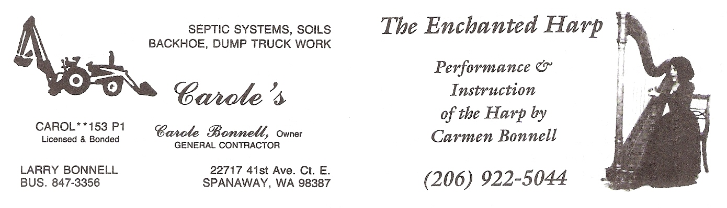
Carole Bonnell, Spanaway, WA, sent me these two business cards "in case you collect Bonnell" cards." It's a nice idea that I hadn't thought of myself, so these will be the start of my collection. I'll count on all my subscribers to find more of them to send in.

Carole is the wife of Larry Allen Bonnell CB370162. Carmen Bonnell is their daughter-in-law, wife of Dean Allen Bonnell CB380008. Larry is descended from William Bunnell through Benjamin, Benjamin, Gershom, Isaac (a Loyalist), Daniel, Daniel Bonnell, Alfred Murray, Oliver Hartley, Hartley Temple, Burt Kieth, Larry Allen Bonnell.

Phyllis Brunk, West Carrollton, OH, reminds us that the first Bunnell reunion of the season will be held at 12:00 noon on 6 June1993 at 50 Springs off Rt. 73 at Caesar's Creek, Harveysburg, OH. They plan -to eat at 1:00 p.m. Bring a meat dish, vegetable, and dessert to share and soft drinks, plates, silverware, etc. and lawn chairs for your family. This is the reunion of the family of Bert and Lucy (Hoover) Bunnell, but other Bunnells and Bonnells would be+ welcome. This would be a good place to begin to grow the reunion.

MILESTONES

I received a letter from Lilly May (Bonnell) Lee of Sun City, CA, which underscores the fact that, while all of us are mortal, it is the family that continues. This, I suppose, is the whole point of genealogy. Here is her letter:
"Dear Mr. Austin:
Sorry I am so late with my Bunnell/Bonnell Newsletter subscription renewal.
I have had so much happen. First our son Vernon Lee had a heart attack, Aug. 14, 1992 and on Oct. 24, 1992 passed away.
Then on Nov. 21, 1992 our granddaughter Nancy Tuttle had her home in Katy, Texas destroyed by a tornado.
We did have a little good news. Our great grandson & his wife Stephanie had a little boy, Devin Robert Lee, and our great granddaughter Rebecca (Lee) Poolaw and her husband Danny had a little girl, Davana Jade Poolaw. So Earl and I are great great grandparents.
Sincerely
Lilly May (Bonnell) Lee"

Mrs. Lee should not have worried about being late with her renewal. Many subscribers, with less grief to cope with, were later. Along with sincere sympathy on the death of their son, I must offer congratulations to Mr. and Mrs. Lee on the start of yet another generation.

[Mrs. Lee is the daughter of Thomas Jackson Bonnell CB341924. Her descent is as follows: William, Nathaniel, Isaac, Abraham, John, Charles, William Martin, Thomas Jackson and Lilly May Bonnell.-wra]

* * *

In the last Newsletter I printed the obituary of Charlotte E. Bunnell, Conneaut, OH, widow of Fay Bunnell, asking for additional information about the family. Jack Mowry, North East, PA, who sent in the clipping originally, called two of the surviving sons, Richard and Paul, and learned that their father was Fay James Bunnell, son of Judson. With this information I was able to determine from Claude Bunnell's database that Judson O. Bunnell CB008758 was born in July 1858 in Pennsylvania. In 1885 he married Emma M.____, who was born in May 1856, also in Pennsylvania. They had six children, two of whom apparently died young. Those that were still living in 1910 were:
CB008759 William A., b. Nov. 1885 PA
CB008760 Lena G., b. Nov. 1888 PA
CB008761 Irene M., b. May 1893 PA
CB008762 Fay James, b. Mar. 1896 PA.
They appear in the 1900 census in Springboro, Crawford co, PA, and in the 1910 census in Monroe, Ashtabula co, OH. Judson was a blacksmith.

Paul Bunnell gave Jack the names of other family members which make it clear that Judson was somehow closely connected with the Aaron W. Bunnell who was born in New Jersey 13 April 1824 and who moved with his parents, Samuel and Rebecca (Hetfield) Bonnell, to Linesville, Crawford co, PA, in 1836. He married Susan Adelia Irons (whose own maternal grandmother was Susannah Bonnell). I couldn't determine just how Judson Bunnell fitted into this family and have written to Paul Bunnell for further information.
* * * * * * *
Barbara Lee Lewis, Hayward, CA, passed along a clipping from the Pasadena, CA, Star-News of 21 October 1992 which was sent to her by her aunt Lots Bunnelle Reid:

Erika Hansen of Lake Forest and Mark Jones of Costa Mesa were recently married by the Rev. Dennis Sherman at the Irvine Community Church in Irvine..
Erika is the daughter of Marilyn and Eric Hansen of Lake Forest. She is the granddaughter of Josephine and Richard Hansen of San Marino, and Doris and Barton Bunnell.
Mark is the son of Vera and Ralph Jones of Costa Mesa. He is the grandson of Freda and Alfred Jones, and Johann and the late Franziska Gruschka.

[Can anyone tell me any more about Doris and Barton Bunnell? The National Registry of Living Bunnells shows a Barton Bunnell living (in 1990) at 2560 N 19th Street, Coos Bay, or. Could this be the bride's grandfather?-wra]

* * *

Claude Mitchell, Muskegon, MI, sent in his cousin's obituary:

THERESA HALT

BERRIEN SPRINGS — Theresa "Muggs" (Bunnell) Halt, 63, of North Main Street in Berrien Springs, died Thursday [17 December 1992] at Berrien General Hospital, Berrien Center.
The funeral will be held at 11 a.m. Monday at the McLauchlin-Hoge Funeral Home, Berrien Springs. Friends may call at the funeral home from 2 to 4 p.m. and 7 to 9 p.m. Sunday where Eastern Star services will be conducted at 3:30 p.m. Sunday by the Welcome F. Mason Chapter 296, Order of Eastern Star, of which she was past matron. Burial will be in Rose Hill Cemetery. Memorials may be made to the Berrien Springs Public School Library.
Mrs. Halt was born March 13, 1929, in Berrien Springs, and was a lifelong resident. She had been employed as an aide in the Berrien Springs Public Schools for 21 years before retiring in 1989. Survivors include: Her husband, Homer; a daughter, Marcia Bennett of Three Rivers; a son. Marc of Naperville, Ill.; one granddaughter; and a sister, Elaine Kellogg of Sodus.

[Theresa Marguerite (Bunnell) Halt was the daughter of Benjamin Jacob Levi Bunnell CB351596. Her descent from the immigrant ancestor was: William, Benjamin, Benjamin, Solomon, Isaac, Henry, James, Jacob Walter, Fred Augustus, to her father Benjamin' Jacob Levi Bunnell.]

* * * *

Although he missed getting the obituary, Mitch also notified us of the death of Glenn Daniel Bunnell CB370332 of Muskegon, MI. Glenn was born 18 September 1927 and died 24 May 1991. His descent was: William, Benjamin, Nathaniel, Abner, Abner, Chester, Chester, Ambrose, William Ezra, John Arthur, Carl Teddy, Glenn Daniel Bunnell.

* * *
Clifton C. Cilley, Colebrook, NH, submitted this obituary from a New Hampshire newspaper of 10 September 1992:

CLAREMONT — Marion M. Bunnell, 92, formerly of 243 Broad St., died Sept. 8, 1992, in Sullivan County Nursing Home after a long illness.
She was born in Hebron, Prince Edward Island, the daughter of Dominick and Rosanne (Maclntyre) Murphy, and had been a resident of Claremont for most of her life.
Mrs. Bunnell had been employed as a cook in restaurant work for Zig Heller and his successor, Tom Buckley.
She was the widow of Newton Bunnell who died in 1959.
The family includes five sons, Norman Bunnell, George Bunnell, Herman Bunnell, Donald Bunnell and Paul Bunnell, all of Claremont; three daughters, Kay Ferguson and Rosanne Gratacos, both of Claremont, and Elsie Bailey of Morgantown, W.Va.; 35 grandchildren and numerous great-grandchildren and great-great-grandchildren; a sister, Elizabeth MacGregor of Newburyport, Mass.; and several nieces and nephews.
A mass of Christian burial will be celebrated tomorrow at 11 a.m. in St. Mary Church. Burial will be in St. Mary Cemetery. Memorial contributions may be made to the Claremont Soup Kitchen Inc., P.O. Box 957, Claremont 03743; or to the charity of one's choice.

[Mrs. Bunnell's husband was Newton Burl Bunnell CB008225. He was the son of Alva and grandson of Horatio Nelson Bunnell. So far we have been unsuccessful in learning the parentage of Horatio, but I suspect he was the son of Seth A. Bunnell CB310116 by a first wife. Can anyone offer any evidence either to support or to contradict that idea?-wra]

* * * * *

The following obituary appeared in the Press-Sun Bulletin, Binghamton, NY, Thursday, 18 February 1993:

Cornelius P. (Kenny) Bunnell, 83, of Port Crane, passed away Tuesday, February 16, 1993 at Wilson Hospital. He was predeceased by his wife, Eleanor (Zablosky) Bunnell. He is survived by two daughters and sons-in-law, Dora E. and Robert Hall, Port Dickinson, Bonney Bunnell and Robert Dehais, Endicott; one son and daughter-in-law John and Carol Bunnell, Port Crane; nine grandchildren and their spouses. Randy Hall, Robin and Michael Maine, Tammy and Stephen Lamond, Laurie Kelly, Lisa and Steve McKercher, Theresa Neiss, Jessica Neiss, Veronica and Margaret Dehais; 11 great-grandchildren; one brother and sister-in-law, Hugh and Mary Bunnell, Johnson City; also two sisters-in-law; several nieces, nephews and cousins. He attended St. Catherine's Church in Hillcrest, and was a retired employee of the Endicott Johnson Corporation with over 30 years of service.
Memorial services will be held for Cornelius and Eleanor Bunnell at the J. F. Rice Funeral Home, Inc., 150 Main St., Johnson City, Saturday at 11 a.m. with the Rev. Lawrence J. Lord officiating. Burial will be in Vestal Hills Memorial Park. Those wishing may make contributions to Catholic Charities of Broome County, 232 Main St., Binghamton, NY 13905 in Cornelius Bunnell's memory.

[The descent of Cornelius P. Bunnell CB351426 is: William, Benjamin, Benjamin, Solomon, Benjamin, John, George Nesbit, Charles Marsh, George Nesbit, Cornelius P. Bunnell.-wra]
Lyda Cloud, Locust Grove, OK, sent in this obituary of her sister-in-law, Helen (Goyer) Bunnell from The Daily Tines, Pryor, OK, Sunday, 5 April 1992:

Funeral services for Helen Bunnell, 82, of Pryor will be held at 11 a.m. Tuesday in the First Presbyterian Church in Pryor.
The Rev. Ivan Rymes and Rev. Glenn Lewis will officiate.
Interment will follow in the Fairview Cemetery of Pryor under the direction of Key Funeral Home of Pryor.
Mrs. Bunnell was born Oct. 6, 1909 in Collinsville. She died April 3, 1992 in Pryor.
She grew up and attended school in Salina, and attended Northeastern State Teachers College in Tahlequah, graduating in 1936.
She was married to Ray Bunnell on Feb. 21, 1939 in Locust Grove.
She taught school in Locust Grove, Spavinaw and the Welch community and, in Salina, she taught first grade for 39 years, retiring in 1974.
She lived most all of her life in the Boatman and Pryor area.
She was a charter member of the First Presbyterian Church in Pryor, and was a member of the Retired Teachers Association, the Oklahoma Educators Association (OEA) and National Educators Association (NBA).
Survivors include two sons and daughters-in-law. Marc and Barbara Bunnell of Adair and Mike and Pam Bunnell of Pryor; one daughter and son-in-law, Linda and David Stephens of Chouteau; seven grandchildren; and five great grandchildren.
She was preceded in death by her husband. Ray, in 1983, two brothers, one sister and a foster daughter, Betty Goyette.

[Mrs. Bunnell was the wife of Ray Ferril Bunnell CB360047. His descent was: William, Benjamin, Benjamin, Solomon, Benjamin, Isaac, John, David, James Smitchell, David James, Frank Rhea, and Ray Ferril Bunnell.-wra]

* * * * *

And this, from the Tunkhannock, PA, New Age-Examiner, Tuesday, 16 March 1993:

ROSE B. MCCROSSEN, 84, of Allen Street, Meshoppen, died Thursday, March 11, 1993 at Tyler Memorial Hospital, Tunkhannock.
Born in Tunkhannock Jan. 27, 1909, she was a daughter of the late John L. and Katherine Gillmartin Bunnell. She was a graduate of Meshoppen High School, Marywood College and The Ohio State University.
She taught school in Marietta, Ohio, and Boston, Mass., prior to retiring.
She was a member of St. Joachim's Roman Catholic Church, Meshoppen, and its Altar and Rosary Society, the Pennsylvania Farmers Association and the Meshoppen Women's Club. She was one of the organizers of the Red Cross in Wyoming County and a volunteer worker with Legal Aid of Wyoming County. She was also a volunteer teacher at St. Michael's school in Hoban Heights.
She was preceded in death by her husband, Vincent A., in 1976; brother, J. J., in 1989.
Surviving are a sister, Margaret Bunnell, Cranford, N.J.; one niece and two nephews.
The funeral was held Saturday from the Sheldon Funeral Home, Main Street, Meshoppen, with a Mass of Christian Burial in St. Joachim's Church, with the Rev. Patrick McDowell, pastor, officiating.
Interment, Overfieid Cemetery, Meshoppen.

(Cont’d)
Obituary of Rose McCrossen (cont'd):

[Mrs. McCrossen's father, John L. Bunnell CB330824 was descended from the immigrant ancestor as follows: William, Benjamin, Benjamin, Solomon, Benjamin, James, Barton Russell, John L. Bunnell.-wra]

* * * * * *

Jane Bailey, Miamisburg, OH, wrote to say that she needs help in proving the date of marriage of Stephen Bunnell CB300135, born 1731 in Scotch Plains, Essex (now Union co), NJ. He is said to have married Mary Daniels, widow of Nathaniel Blackford, in 1754.

NEW JERSEY MARRIAGE RECORDS, 1665-1800, by William Nelson, page 647, gives the marriage of Nathaniel Blackford and Mary Daniels 20 August 1759 in the Scotch Plains Baptist Church.

NEW JERSEY COLONIAL DOCUMENTS, CALENDAR OF WILLS—1761-1770, pages 44 and 45 lists this abstract:

" 1764, March 25. Blackford, Nathaniel, of Piscataway, Middlesex Co.; will of. Wife, Mary, use of my plantation to bring up my children. Sons, John, Benjamin and Nathaniel, my farm when they are 21. My daughter, Desia Blackford, £100. Daughter, Sophia, £100. I give to my daughters the pewter that did belong to my first wife. Executors—my wife, and my brother, John Blackford. witnesses—John Smith, Stephen Bunels, Daniel Barto. Proved April 12, 1764.
1764, April 11.
Inventory, £252.19.11, made by Jacob Boice and John Hepburn. Lib H, p. 337."

Mrs. Bailey rightfully points out that, unless there is another Mary (Daniels) Blackford, either Stephen and she were not married in 1754, or Stephen's wife was someone else entirely. After diligent search Mrs. Bailey has not been able to discover a marriage record for Stephen. Neither have I.

The problem is further complicated by the fact that I can find a contemporary record of the birth of only one of Stephen's eight children - Stephen, Jr., whose family Bible states he was born 25 June 1767. Even that was written many years after his birth, probably by Stephen, Jr., himself.

I have received lists of the eight children from a number of different correspondents over the years. Most of them, with only slight variations, look like this:
1. James, b, abt. 1755.
2. Jonas, b. abt. 1759.
3. Brazilla, b. abt. 1761.
4. David, b. abt. 1764.
5. Stephen, b. 25 June 1767.
6. Nathaniel, b. 3 July 1778.
7. Rhoda, b. 1780 (or 1777).
8. Mary. b. 1782 (or 1779).

These birth dates would be consistent with a marriage date in 1754. While there is considerable agreement among most of the sources, I

Marriage of Stephen Bunnell (Cont'd)

suspect that they all go back to one original source. It seems a little odd that nearly all my correspondents used the abbreviation "abt." for about instead of the more usual "c." or "ca."

Nona Bassett, Merced, CA, at different times sent me two different Family Group sheets she compiled for Stephen and Mary (Daniels) (Blackford) Bunnell. In the first, the children's birth dates are listed as above, and Nona gave as her source Nina Osborn Roberts. In the second FGS, however, Nona gave 1764 as the marriage date for Stephen and Mary, and she listed the children as follows:

James, b. c. 1765.
Stephen, b. 25 June 1767.
Jonas, b. c. 1769.
Brazilla, b. c. 1771.
David, b. c. 1773.
Nathaniel, b. 3 July 1778.
Rhoda, b. c. 1777.
Mary, b. c. 1779.

No references were shown for the source of these dates. If they are correct, however, they eliminate the difficulty in the marriage of Stephen Bunnell to the widow of Nathaniel Blackford. Therefore, in an effort to answer Mrs. Bailey's question, I have dug through all the references I have found for each of these people searching for proof that Stephen and Mary had children born before 1765.

As noted above, no marriage record for Stephen and Mary has been found. Nor do I find any evidence to support the dates of birth of James, Jonas, Brazilla and David, the four children said to have been born in 1764 or before. Claude Bunnell's Database does provide a more specific date of birth for Jonas: 29 August 1759, but Claude does not know the source for the information.

Nothing that I have found hints at the age of any of these four children at any time in their lives. James was married, but I don't find a date. Brazilla never married. David married on 19 March 1796 when he was either 32 by the first list or 23 by the second. Either is possible.

Jonas married Sally Tomlin, as his first wife. Although the record is not completely clear, it would appear that Jonas and Sally had their first child on 14 October 1791, and then followed up with eight more children before Sally died in 1807 or 1808. A marriage date of about 1790 is suggested in one record, which seems likely. Jonas would have been 31 by the first list and 21 by the second. Again, either is possible.

If the Database is correct in stating the date of birth for Jonas, then clearly Stephen's wife could not have been the widow of Nathaniel Blackford. However, that single piece of unconfirmed data is all that we have to support the first set of birth dates. Somewhere there must be a solid reference to the age of at least one of these four children. Until we find it, it would seem that there is nothing in the record to preclude either list from being the correct one.

* * * * * * *
Louise Nemecek, Richmond, VA, asked me to print these two pictures to see if anyone could recognize any of the people in them. Her father Frederick Hartsok Bunnell, CB352146, was born 8 December 1897 in Washington, DC, and died 16 January 1966 in Richmond, VA. Due to the early death of his parents, he was raised by two cousins, the sisters Frances and Joanne E. Corr. They lived in Richmond at the time these pictures were taken. In the first picture, Frederick Hartsok Bunnell (Freddy) is the middle one of the three boys. Who are the other two?

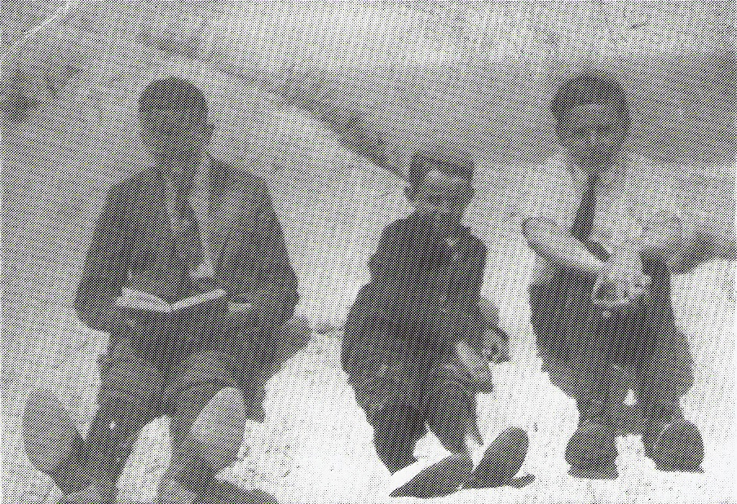

In this picture Freddy is the little boy in the middle background. His cousin Joanne E. Corr is sitting second from left. Does anyone know any of the other girls or the boy with the dog?

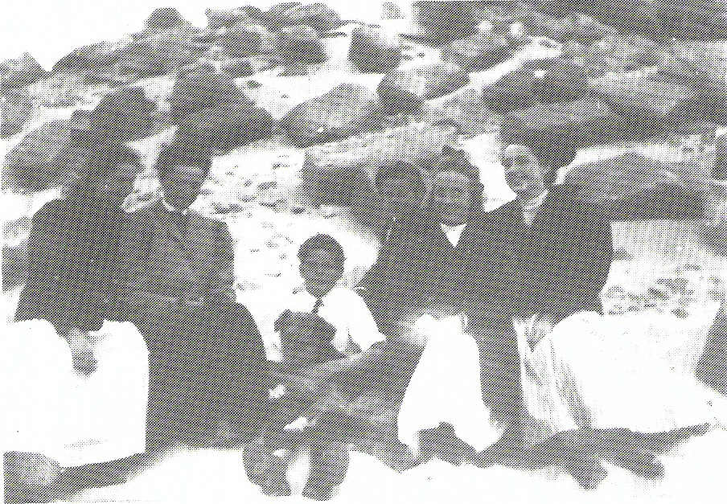
At an auction I bought a copy of the 1971 issue of OUTSTANDING AMERICAN HIGH SCHOOL STUDENTS. On page 94 I found:

BUNNELL, Sharon Kay, Trenton High School/ Trenton, NE. Co-Editor of the Annual; Chorus; Ensemble; President, 4-H; Madrigal; School Paper; Secretary/Senior class; secretary. Junior Class; Secretary-Treasurer, Sophomore Class; DAR Good Citizen Award; Elk Award; 4-H Award; Honors Program; Voice of Democracy; Home Economics Award; plans to enter McCook Junior College to study Business.

Miss Bunnell would probably be about 40 years old by now. I have not discovered a Bunnell family in that part of Nebraska before. The NATIONAL REGISTRY OF LIVING BUNNELLS lists three names in McCook, NE: Dave Bunnell, 306 W. 3rd St., David A. Bunnell, 1307 W. 1st St., and Ray E. Bunnell, 106 S. 9th St. Trenton is the county seat of Hitchcock co, NE, and McCook is the county seat of Red Willow co, next county to the east, both on the southern border. Can anyone add more info?

* * * * * * *

QUERIES

The name and address of the inquirer are included with each query. However, if you are able to provide the inquirer with the information requested, I would appreciate your sending me a copy of your reply.

1. BENJAMIN P. BUNNELL, born ca 1800/1814 Pennsylvania, married 21 Oct. 1837 Portage co, OH (I have a copy of marriage record) LUCY E. SIMMONS. They had two children, CONSTANT P., born 1839 Summit co, OH, and THOMAS C., born 1842 Summit co, OH. On 8 June 1848 Summit co, OH, LUCY E. BUNNELL married SHADRACK WILLEY. They named their first and only son GEORGE BUNNELL WILLEY. What happened to BENJAMIN P. BUNNELL, and when and where did he die?

1850 census, Medina co, IA, shows SHADRACK WILLEY, along with CONSTANT BONNELL, THOMAS C. BONNELL, and SYBLE BONNELL, age 1. (Her surname is probably in error. Her death record gives her maiden name as WILLEY.) I860 census. Summit co, OH, shows CONSTANT BUNNELL in household of an OSBORNE as a hired hand. His Civil War veteran papers show him as BENJAMIN FRANKLIN BONNELL (the name I have always known him by); therefore he apparently changed his name from Constant P. to Benjamin Franklin before entering the service.

On the 1925 Iowa State census he stated that his parents were married in Summit co, OH. (Summit co was formed in part from Portage co in 1840.) One would think that Benjamin P. would be with his parents in 1830, perhaps in Portage co. Could Benjamin P.'s middle name be taken from his father's name rather than the Benjamin? Or could his father have been Thomas, since he named his second son by that name?

Since Benjamin P. was born somewhere in Pennsylvania, surely someone has some data from Pennsylvania to Portage co, OH. I desperately need help Mabel Daniels, 301 Sherman St.. Beacon. IA 52534-9711.

* * * * * * *

That's all for this time. I ran out of room, so I had to skip the IGI for this quarter. Perhaps there will be more room in June.

